FAQ
ENER314-IR
- How do I mount my IR board on top of my Raspberry Pi?
Connect the add on board to the top 26 pins. The Infrared emitters and detectors should be facing the same direction as the SD card.
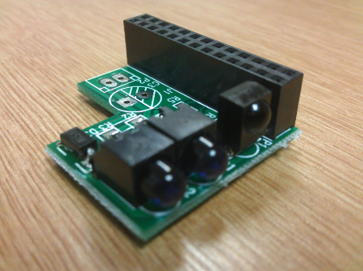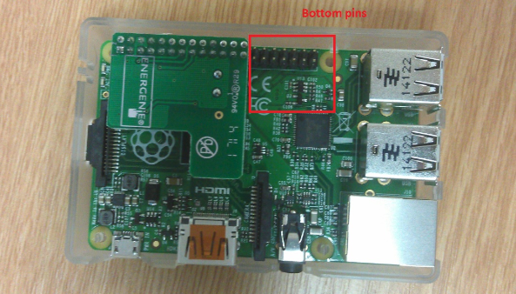
- How do I find the config file for my remote?
You can find hundreds of remotes at:
http://lirc.sourceforge.net/remotes/
Just select a make and model. Copy the content of the config file into lircd.conf using the following command:
sudo nano /etc/lirc/lircd.conf
note: not all remote configurations will be available on the LIRC index because not all remotes are supported by LIRC. In this circumstance please be advised to use the previous method of generating an LIRCD config file using irrecord
- How do I generate my own config file?
You can use the irrecord program. This program will allow you to record the signals from your remote control and create a configuration file.
Make sure lircd isn't running, you have to kill the process before irrecord will work eg.:
sudo killall lircd irrecord --list-namespace | grep KEY

Follow the instructions on the bottom of page 5 on the user guide to learn how to operate the irrecord application
- Why won’t the LIRC program run?
Try to restart the LIRC program using the following command:
sudo /etc/init.d/lirc restart

